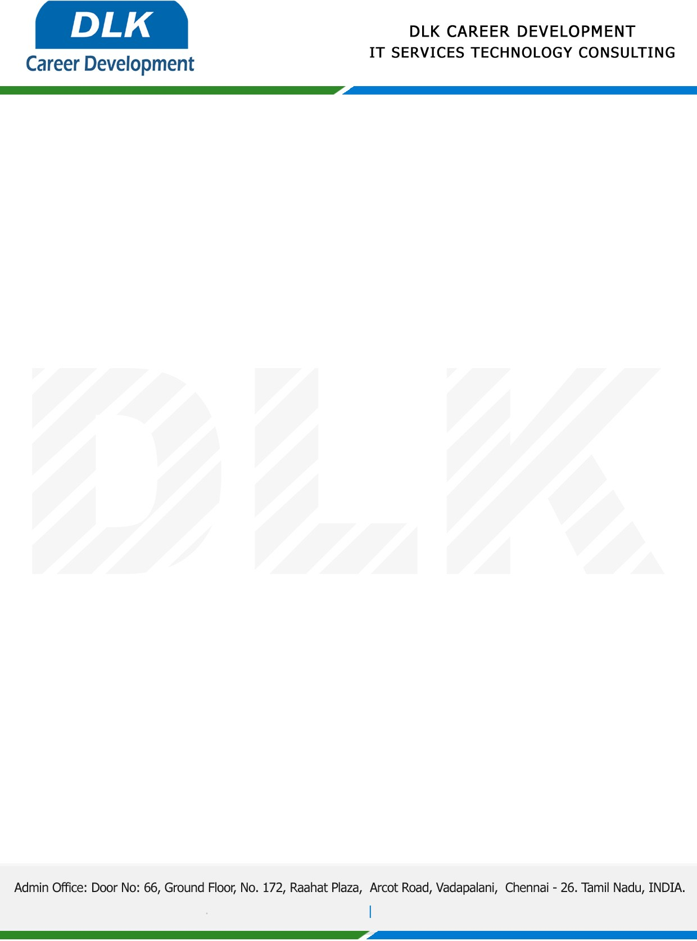

**Date: 11/ February /2023**

**SUB: INTERNSHIP COMPLETION CERTIFICATE**

This is to certify that **MR** **NAVEEN L (REG NO:** **VM13892) B.Tech - Artificial Intelligence and Data Science**  second year student of **Vel Tech Multi Tech Engineering College, Chennai** has Successfully Completed the Internship Work under the domain of **“Python with Artificial Intelligence”** in our organization during the Period **(23rd January 2023** to **11th February 2023).**

We appreciate your interest in **DLK CAREER DEVELOPMENT**

**“Best Wishes for Your Future Endeavors “**

For **DLK CAREER DEVELOPMENT**

**HR Manager**

**VELMURUGAN J**